Sleep disorder analysis

G.N. Venkatapathiraju (B122048) Ishan Singh (B122056) Rishit Parija (B122093)

IIIT Bhubaneswar

Data Science and AI in Health Care

Sleep Disorder Analysis Report

# 1. Project Goals

The core objective of this project is to create an AI-powered model capable of accurately classifying sleep patterns into three distinct categories: **Insomnia**, **Sleep Apnea**, and **Normal Sleep**. By leveraging machine learning techniques, the model can identify subtle differences in sleep data that may indicate potential disorders.

In addition to model development, the project aims to build an intuitive and accessible web-based platform. This platform allows users to upload their sleep data effortlessly and receive near-instant results, empowering individuals to take proactive steps toward improving their sleep health.

Furthermore, this initiative promotes early detection of sleep-related issues, facilitating timely medical consultation. By catching symptoms early, individuals can potentially prevent long-term complications associated with untreated sleep disorders.

The platform also serves as a valuable diagnostic tool for healthcare professionals, enabling them to assess patient sleep patterns efficiently and make data-driven treatment decisions.

# 2. Methods

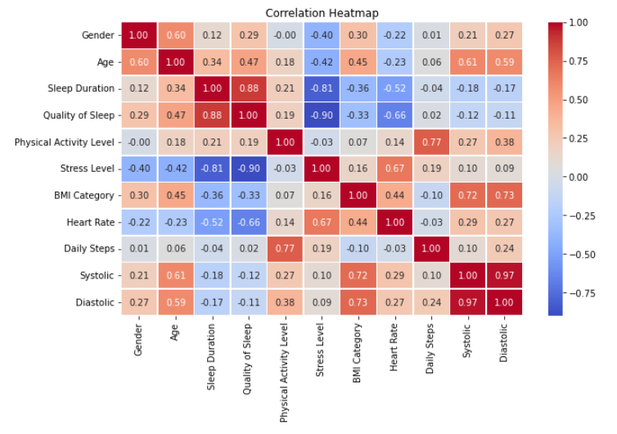To achieve optimal model performance, the project employed several data preprocessing techniques. A Heat Map was generated and used to determine the correlation amongst various features of the used dataset.

**Principal Component Analysis (PCA)** was used for feature selection and dimensionality reduction. This technique removes redundant or irrelevant features, enhancing model efficiency and reducing the risk of overfitting.

Additionally, **Min-Max normalization** was applied to standardize the dataset by scaling the values to a specific range. This step ensures that no individual feature dominates the training process, promoting balanced learning and improved accuracy.

Multiple machine learning algorithms were implemented and evaluated to determine the most effective model. These included:

• **Linear Regression**: Used for baseline performance measurement but proved inadequate for complex sleep disorder classification.  
• **Logistic Regression**: More effective for binary classification but lacked accuracy in multi-class classification.  
• **Support Vector Classifier (SVC)**: Demonstrated moderate performance.  
• **Random Forest**: Provided better accuracy and stability but was still outperformed by Neural Networks.  
• **Neural Networks**: Exhibited the highest accuracy and generalization capabilities, making it the optimal choice for deployment.

To evaluate the models, we used comprehensive performance metrics, including:

• **ROC-AUC Curves**: Indicating the model's ability to distinguish between different classes.  
• **Confusion Matrix**: Providing insights into the distribution of true positives, false positives, true negatives, and false negatives.  
• **Accuracy, Precision, and Recall**: Measuring the overall reliability, consistency, and predictive power of the models.

# 3. Results

The model's performance during validation demonstrated exceptional classification accuracy. The **ROC-AUC score**, which started at **0.7284** in the first epoch, quickly improved, reaching **0.9026** by the third epoch. By the twenty-third epoch, the model achieved a nearly perfect ROC-AUC score of over **0.9992**, highlighting its robust discriminative power.

Validation accuracy also showed significant improvement, reaching **98.67%**, while validation loss steadily decreased. This reduction in loss indicates the model's effective learning and generalization, minimizing false predictions and enhancing reliability.

The confusion matrix revealed a minimal occurrence of false positives and false negatives, indicating high precision and recall. These results affirm the model's reliability in real-world applications, making it a highly effective tool for early disorder detection.

Additionally, the model's consistent performance across multiple validation runs showcases its stability and robustness. This consistency is crucial for ensuring reliable outcomes in practical, user-driven applications.

**Neural Network – Evaluation Metrics**

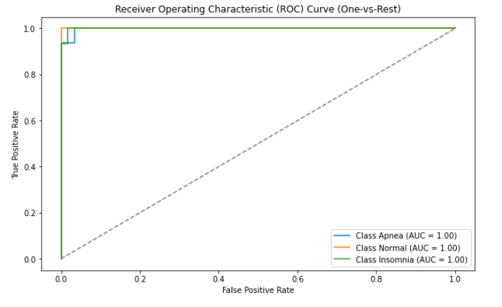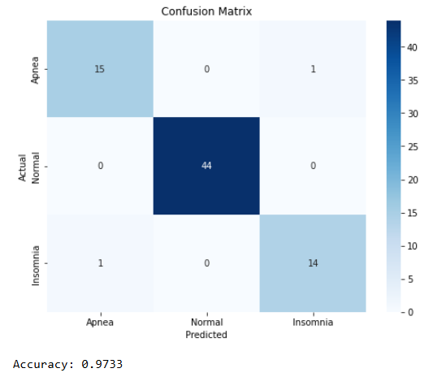

**Random Forest – Evaluation Metrics**

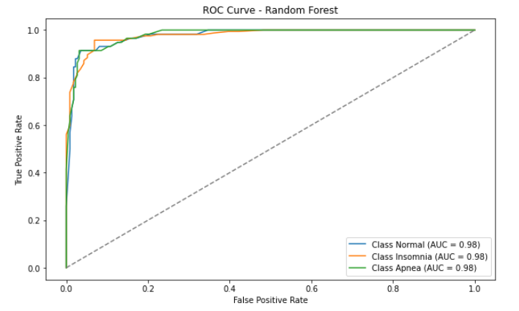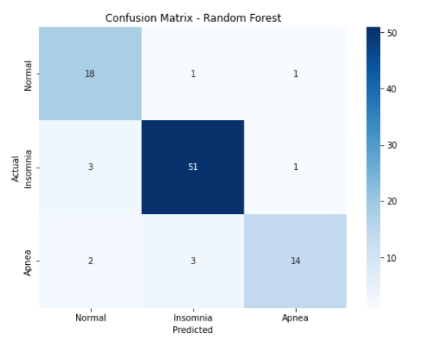

# 4. Conclusion

The AI-powered sleep disorder classification model successfully categorizes sleep patterns into Insomnia, Sleep Apnea, and Normal sleep with exceptional accuracy. The **ROC-AUC score of 0.9992** and **validation accuracy of 98.67%** highlight the model's high performance and reliability.

The use of Neural Networks proved to be the most effective approach, demonstrating superior accuracy and generalization capabilities compared to traditional machine learning models. The web-based platform enhances accessibility by providing users with instant diagnostic results.

This innovative solution offers substantial benefits for both individuals and healthcare professionals. Early detection of sleep disorders can lead to timely intervention, potentially reducing the risk of associated complications such as cardiovascular disease, depression, and chronic fatigue.

Furthermore, the platform's user-friendly interface promotes widespread adoption, empowering individuals to take a proactive role in managing their sleep health. The model's reliability and accuracy make it a valuable tool for future applications in clinical diagnostics and remote patient monitoring.

In the long term, this project has the potential to revolutionize sleep disorder diagnosis by making advanced AI technology accessible to the general public. By facilitating early intervention and promoting sleep health awareness, it contributes to overall wellness and quality of life improvement.

**Links**

**Google Colab:** <https://colab.research.google.com/drive/1LewiePZt-2-0Tz-Xlu4Uyx_-jKFsd-eV?usp=sharing>

**Dataset URL:** <https://www.kaggle.com/datasets/uom190346a/sleep-health-and-lifestyle-dataset/data>

----------- X -----------